ECE492-001
Remote Control Motorized Combat Robot
Jason Haun, Anas Basmaih, Arturo Senzano,
Kevin Cepeda, Shaan Sharma, Kevin Lam

Weapon's Specification and Costs Sheet: Drum Spinner
Summary: The drum spinner is a cylindrical weapon with elevated attack edges along the circumference of the drum. The drum is held to the frame by an axle and is driven upwards by a pair of drive chains and motors. Two versions of this drum spinner have been planned: a single edge drum and a triple edge drum.
Specifications
Triple edge drum: Total diameter: 115mm, Tube diameter: 90mm, Attack edge thickness: 12.5mm. Total weight: ~35lbs.
Single edge drum: Total diameter: 122.5mm, Tube diameter: 110mm, Attack edge thickness: 12.5mm. Total weight: ~27.17lbs.

Advantages: The advantages of using the drum spinner as a weapon are focused on the destructive nature. With the cylindrical design, the weapon is always in an orientation to create havoc as the drum will be able to spin and harm the competitor. Having the robot get flipped will change the direction of the spin from being an upward spin to a downward spin, or vice versa. The spin of the drum provides both the possibility of flipping the competitor's robot and/or ripping pieces of the robot off the frame. The drum will be rotating at a high rate with 25-35lbs of weight leading to a high repetition of blunt strikes to the enemy robot, denting and damaging the opponent.
Disadvantages: The disadvantages to this weapon are its low chances to catch onto the opponent's robot and its high dependence on moving parts. Due to the thickness of the attacking edges and the geometry of the drum, when faced against specific types of robot chassis the drum will have a very difficult time catching onto the frame of the enemy robot. Additionally, the high dependence on drive chains and motors create a major weak point in the weapon as the drum is rendered useless if either the chain or the motor fails to operate properly. These flaws will result in the battle to resort to a pushing fight where the operators will need to use obstacles to displace the competitor's robot such that the drum can catch onto the chassis.
Costs: (Based on Raw materials found on mcmaster.com, before tax and shipping)
- 3ft Carbon Steel Tube, 4.5" diameter(45,000 PSI)($221.76)
- 12"x24" Carbon Steel Sheet, 1/2" Thickness (60,000 PSI)($164.02)
- Tube Substitution 3ft Carbon Steel Rod 4.5" diameter (54,000 PSI) ($381.18)
Total Cost: ($385.78) or ($381.18)
Single Edge Drum
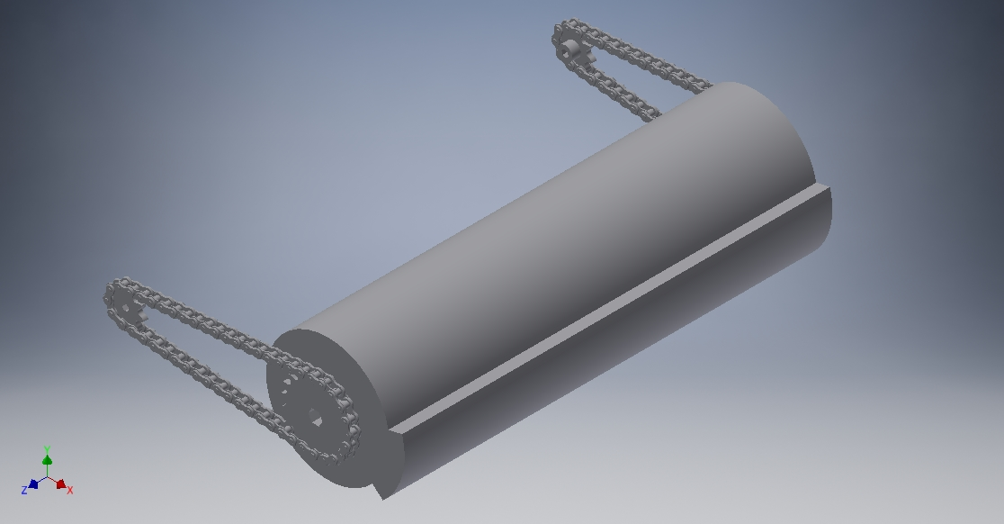

Triple Edge Drum
